Template for Evidence(s)
UI GreenMetric Questionnaire

University : ...
Country : ...
Web Address : …

[1] Setting and Infrastructure (SI)
SAMPLE
[1.10] Total area on campus covered in planted vegetation (meter²) (SI.3)

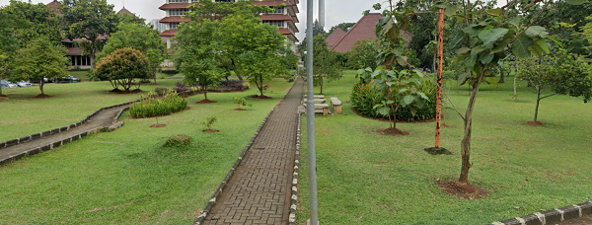 |  | 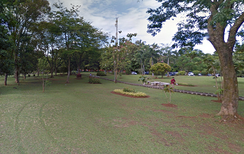
Taman 1 | Taman 2
Example of Total Planted Vegetation Area (Universitas Indonesia, Indonesia)

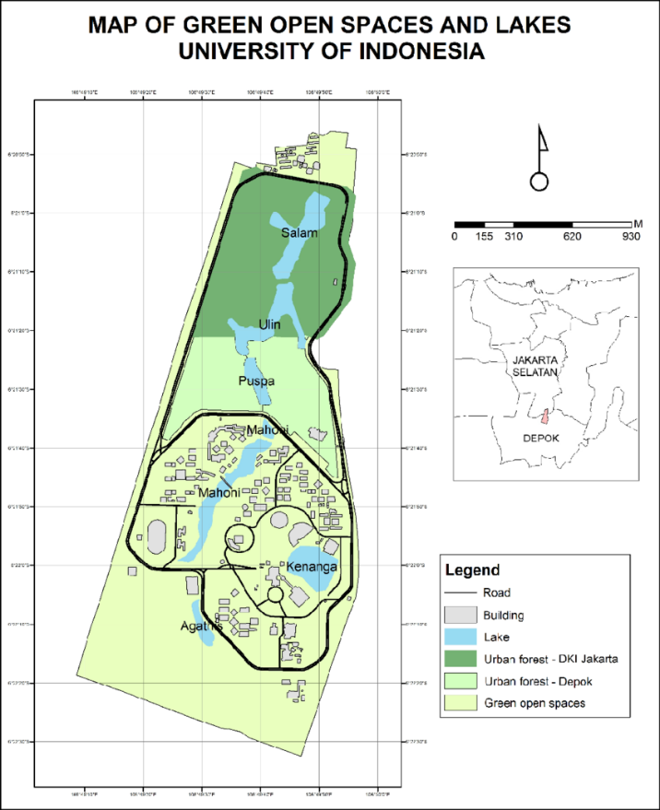

Description:
(Please describe the planted vegetation area in your campus. The following is an example of the description. You can describe more related items if needed.)

All claimed areas must be supported by clear visual evidence, including site maps, building names, and sectional images showing the exact locations of the vegetation areas. The evidence provided may also include maps showing the location, area size, or distribution of facilities relevant to the indicators

Total planted vegetation area: 193,530 m²
Total Area: 454.678 m2
Percentage area: 43%

Additional evidence link (i.e., for videos, more images, or other files that are not included in this file):

